CIS 211 Project 6: SQLite Databases
Haomin He
1. Queries

## My terminal window somehow does not allow me to copy from command line. I used the word document, so that I can use screen shot. Sorry for any inconvenience.

NOTE: some queries (like the first one) will produce hundreds of lines of output. In
these cases add “limit 5” to the end of your query.

- What are the first and last names of all the customers?
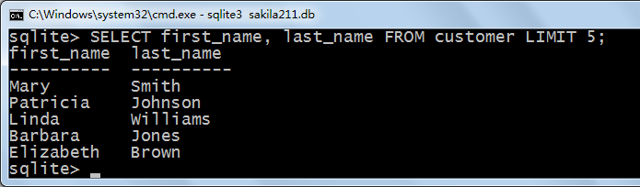

- What are the e-mail addresses of customers whose first name is “Willard”?
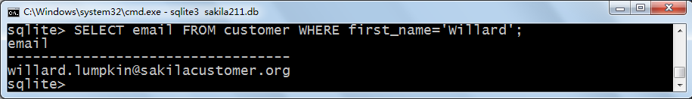

- How many customers are there?
There are 599 customers.
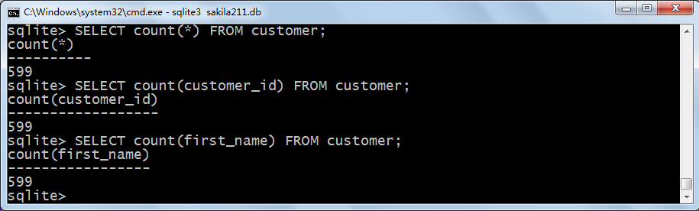

- How many customers shop at store number 1?
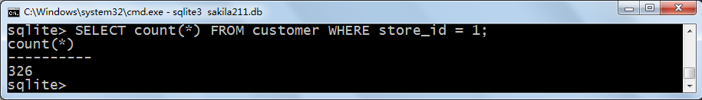

- How much does it cost to rent the film named “Virtual Spoilers”?
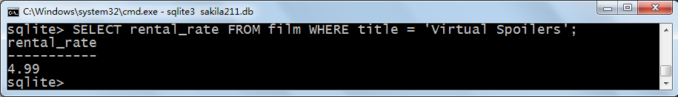

- Do any films have the word “Princess” in the title?
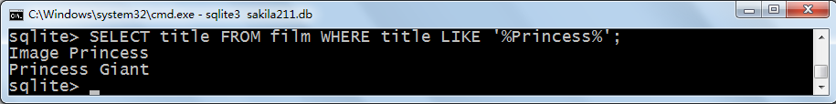

7. What are the titles of the films that are longer than 180 minutes?
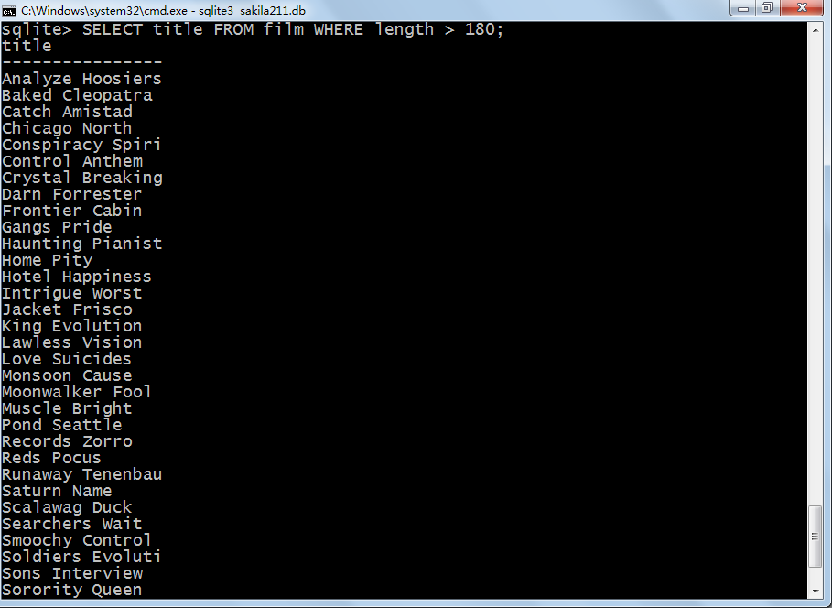
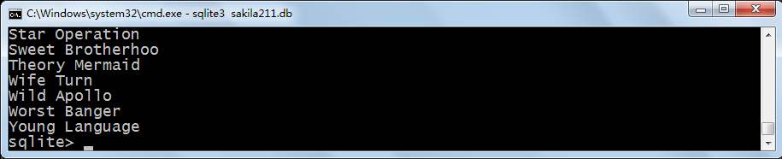

- How many films have a “G” rating and are less than 60 minutes long?
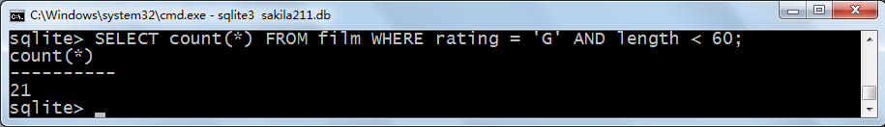

- What is the maximum replacement cost for any film?
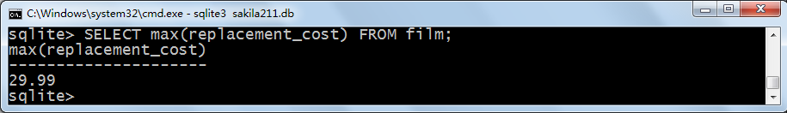

10. Print a table that lists the different types of ratings and the number of films that
have that rating.
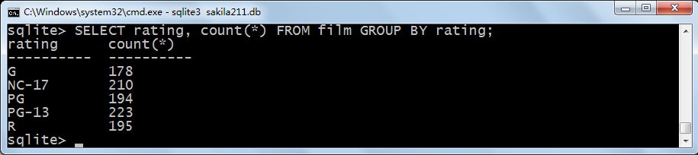

- How many actors starred in the film named “Scalawag Duck”?
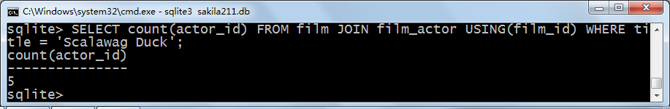

- What are the film IDs of movies starring Jude Cruise?
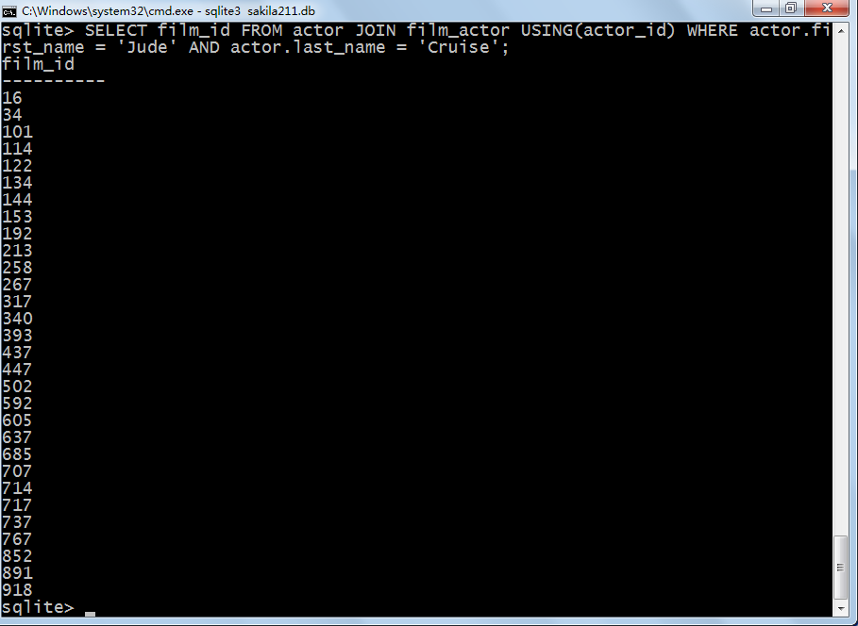

- What language was “Ace Goldfinger” filmed in?
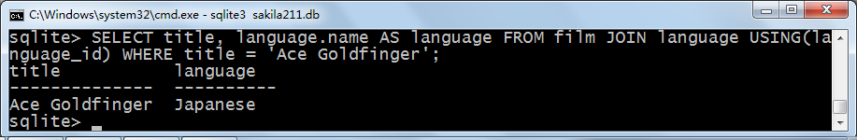

- Produce a table that shows how many films each customer has rented.
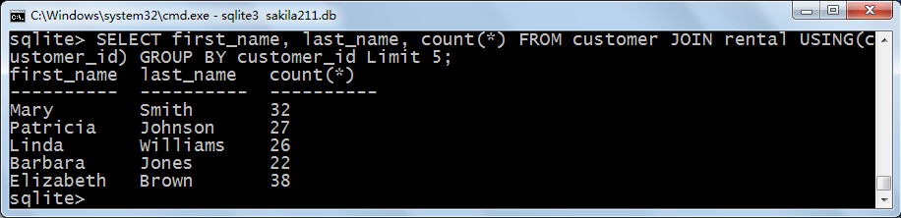

- How many films did the customer named Smith rent?
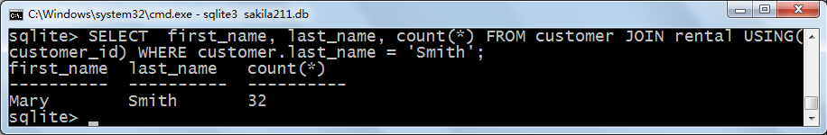

16. Which customers have not returned films (i.e. the return_date field in the rental
table is null)?
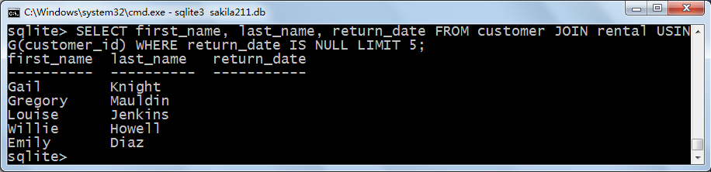

- Which actors starred in “Splash Gump”?
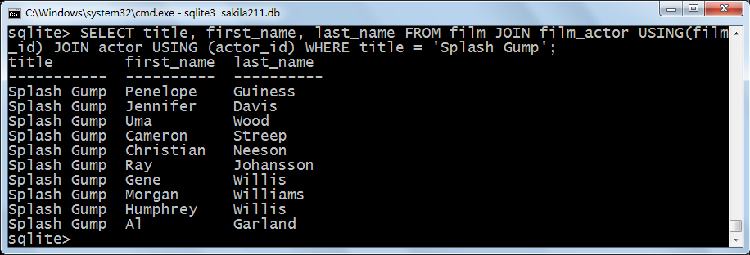

- Which films has Penelope Guiness starred in?
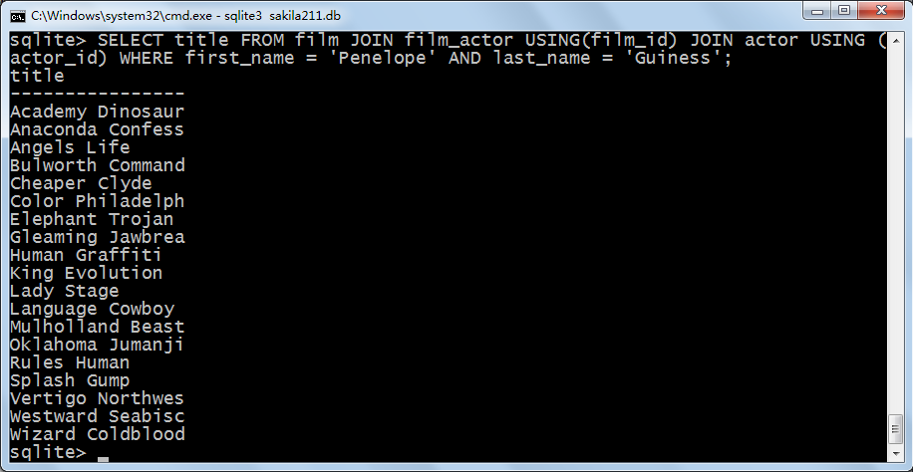

- What are the names of the films rented by the customer named Knight?
